AviCapture

Overview
AviCapture is a small Windows application which connects to a PixeLINK 4.0 camera, continuously records the most recent 10 minutes of images, and when instructed by the user, converts those images to AVI files playable in Windows Media Player.

Setup

AviCapture assumes you have installed PixeLINK API 6.21 (or later) and have connected and configured your camera. The computer to which the camera is connected, the 'host' computer', is the computer on which AviCapture must be run. The host computer must have at least 30GB of free space on a local drive.

Use

After launching AviCapture and being presented with the following UI:

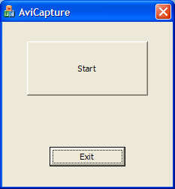

you may press Start to begin recording images from the camera, whereupon you'll see this:

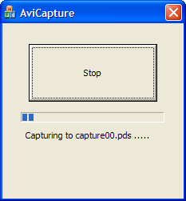

Approximately 30 seconds of images are stored to each of the PixeLINK data stream (PDS) files, named capture00.pds up to and including capture19.pds. The PDS files will be created in the current directory.

NOTE: Just before recording begins, any existing pds files in the current directory will be deleted.

A preview window will be created which may be either resized, minimized, maximized, or closed. If it is closed, it cannot be seen again until the next recording session.

Pressing Stop will present the user with the option of converting the PDS files to AVI files, or simply stopping.

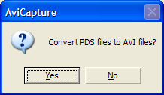

If you chose to convert the PDS files, conversion will begin:

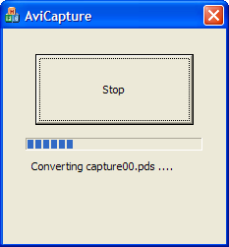

It may take a considerable amount of time -- up to 15 minutes -- to convert all 20 PDS files to AVI files.

NOTE: Existing AVI files in the current directory will be overwritten.

If you want to stop converting, you may press the Stop button,

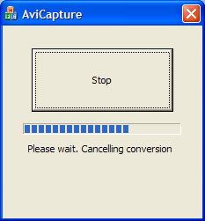

causing AviCapture to stop conversion when it's done converting the current file. Note that it may take some time to complete the conversion of the current PDS file.

Support

If you have any questions, please contact PixeLINK support.

http://www.pixelink.com/support_contact.asp

